**Lance Christiansen, CDTFA**

**BIO**

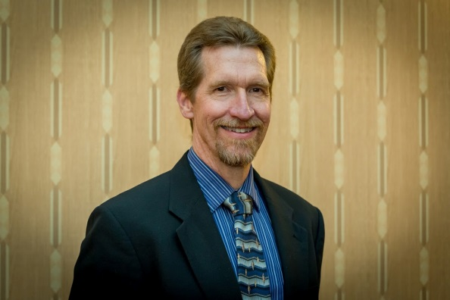

Lance Christiansen is the Information Officer for the California Department of Tax and Fee Administration out of the Riverside office. Lance travels throughout Riverside, San Bernardino, and Orange Counties speaking to groups of small business owners about the ins and outs of Sales and Use Tax. He grew up in Riverside, earned a Bachelor of Science degree in Communications from California State Polytechnic University in Pomona, and now resides in the High Desert town of Apple Valley. Prior to coming to the CDTFA, Lance spent over 25 years as a Program Director in professional radio.