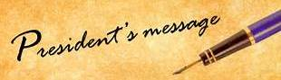
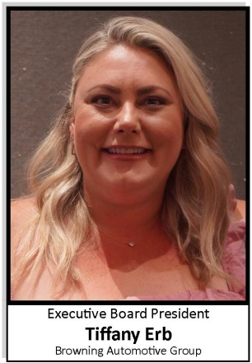

Greetings ADOMA readers,

Spring has officially sprung and we are ready to welcome April! Let us put the rain in the rearview mirror, as we look forward to warmer days.

The ADOMA March meeting was an excellent reminder on how to manage Workers Compensation. Dan Chergey and Taryan Saavedra from Chergey Insurance informed us on how to keep WC claims low, complete audits of position codes and how to review and prepare for a WC audit.

EPIC Insurance Brokers was our platinum sponsor of the month and Ron Joy and Mark Pattinson spoke on all the healthcare benefits EIC offers. Please feel free to reach out to me for more information on these providers.

April 19th at 4:00 is our April meeting and we are excited to share that David Reese from Fine, Boggs & Perkins LLP will be presenting. Mr. Reese will work through a variety of common questions that come regularly from dealerships to the HR Hotlink line. Come armed with questions, as there will be plenty of time for some Q&A. Please sign up today for the meeting to get all your payroll questions answered.

Jeff Gordino from Label Pro is our April platinum sponsor and we look forward to hearing how we can cut expenses on toner and other printing projects.

Time to sign up for the 45th ADOMA education conference in Las Vegas at the South Point hotel! We have selected speakers and topics you will not want to miss. Do not delay in registering for this event. We are looking for sponsors and vendors to sign up for the vendor faire.

Here is the link for the website to register for conference: https://adoma.org/index.php/2023-educational-conference/. Do not forget to add Top Golf on Friday night!

Have a wonderful Easter!

Tiffany Erb
ADOMA 2022-2024
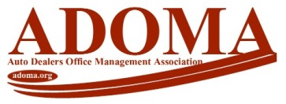
Executive President

